**CS 4345 (Spring 2019) : Unit Test 3 Study Guide**

**Topics that you need to prepare:**

**Chapter 8 (Deadlock):**

• Deadlock characterization (***Section 8.3***)

o Focus on necessary conditions of deadlock

Deadlock can arise if four conditions hold simultaneously.

* **Mutual exclusion:** only one process at a time can use a resource
* **Hold and wait:** a process holding at least one resource is waiting to acquire additional resources held by other processes
* **No preemption:** a resource can be released only voluntarily by the process holding it, after that process has completed its task
* **Circular wait:** there exists a set {*P*0, *P*1, …, *P*n} of waiting processes such that *P*0 is waiting for a resource that is held by *P*1, *P*1 is waiting for a resource that is held by *P*2, …, *Pn*–1 is waiting for a resource that is held by *P*n, and *P*n is waiting for a resource that is held by *P*0.

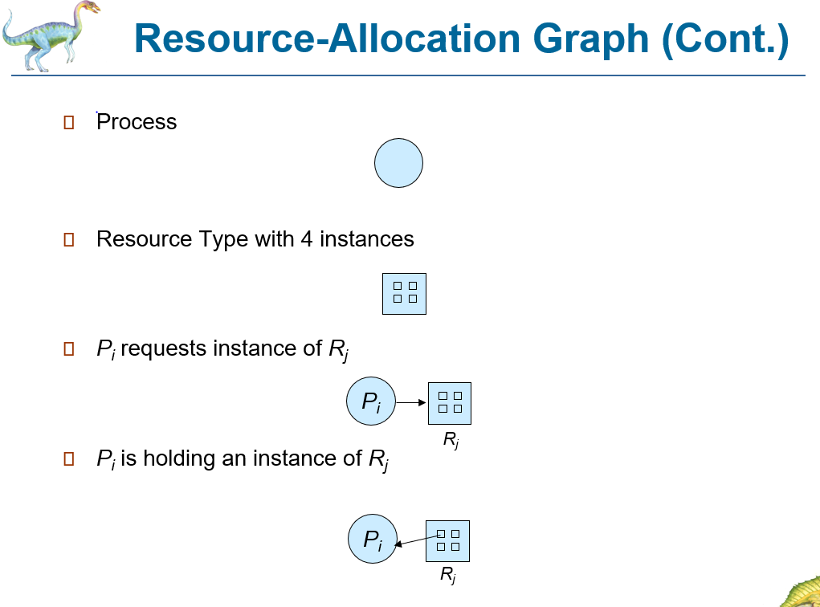o Check how deadlock can be detected using graphical approach

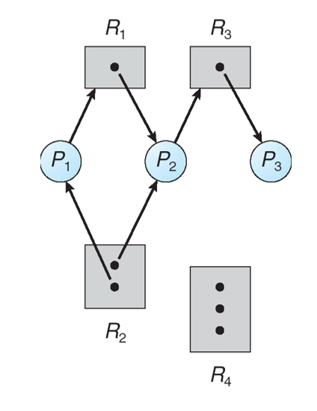

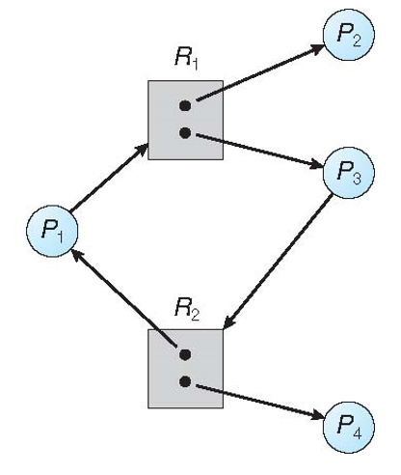

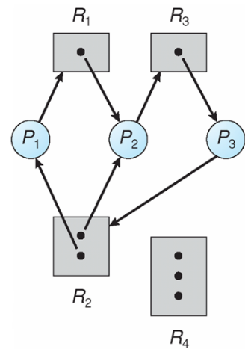

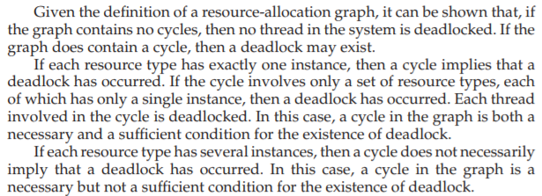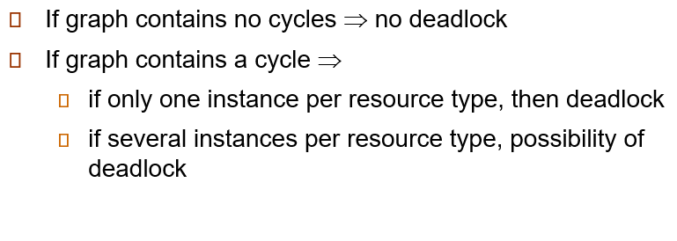



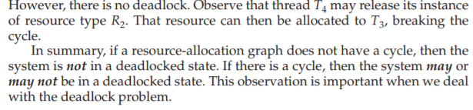

**Chapter 9 (Main Memory)**

• “Contiguous view” of the memory, related issues, and potential solutions to the issues

-Contiguous memory allocation is a classical memory allocation model that assigns a process consecutive memory blocks (that is, memory blocks having consecutive addresses).

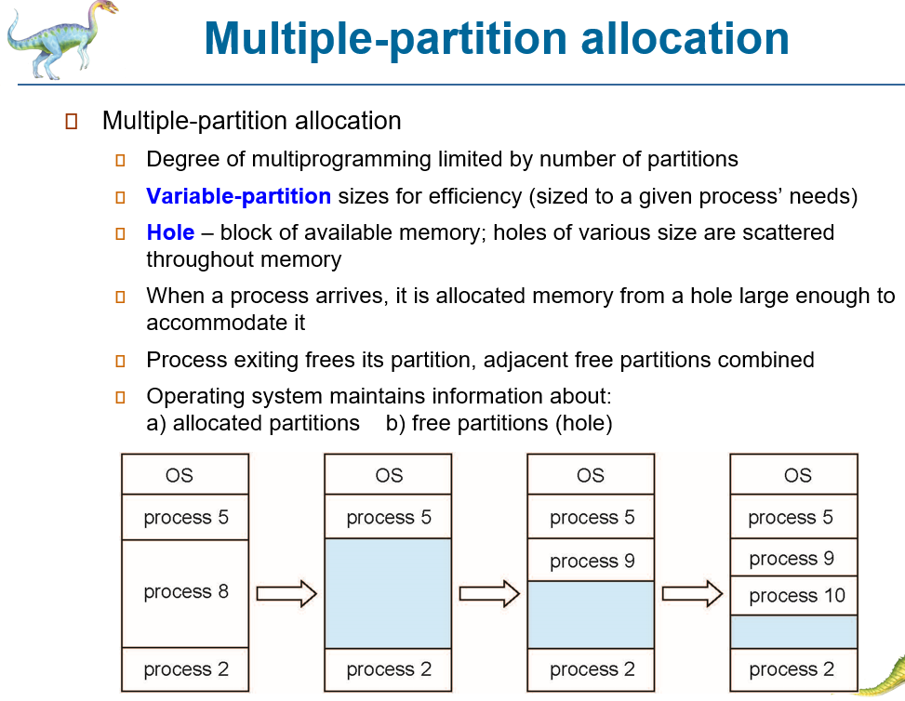

o Focus on basic hardware (base & limit) and how they help in address mapping (***Section***

***9.1***)

* 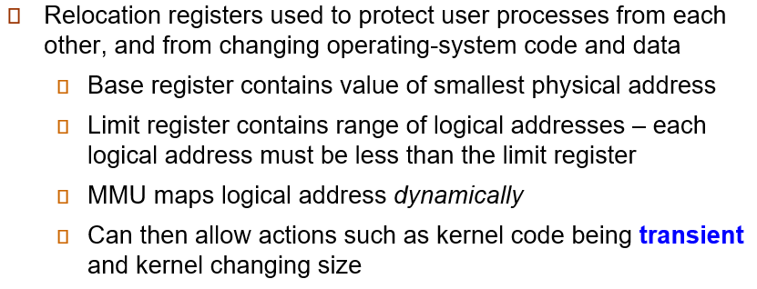

o Fragmentation problems and potential solution in memory allocation (***Section 9.2***)

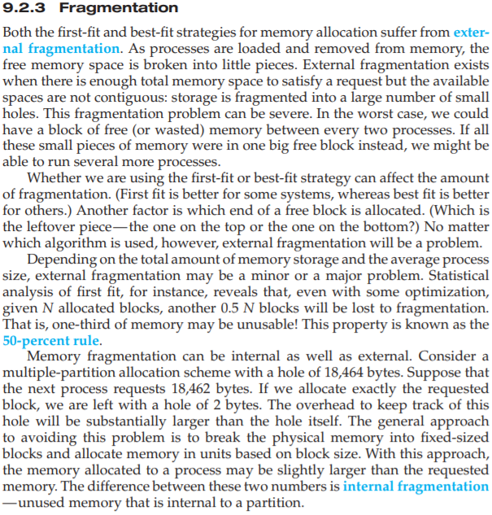

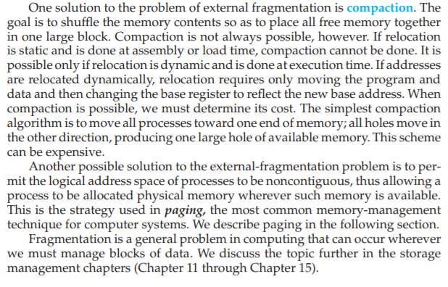

• “Block view” of memory with idea of paging, page-frame association, and page table;

allocation of address space in the form of pages (***Section 9.3***)

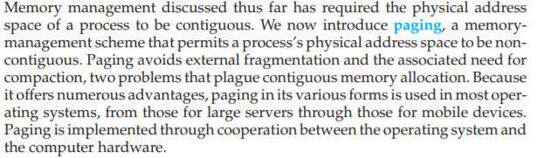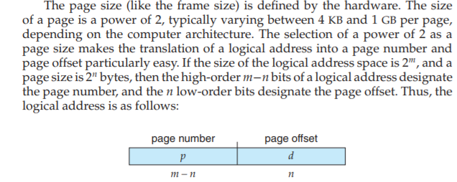

o Focus on how

o check how to find out physical address from given logical address and page table

**General tip/suggestion:**

• Slides are good for preview/overview and for identifying the focus area. However, it is strongly recommended that you read the book to fill in the necessary details and to have better understanding.

• Check the practice questions – some of them could be useful for answering test questions.

• For paging, check numerical problems related to memory mapping and address translation. For example, check how to determine physical memory address from logical memory address using page table entries.

=================== ALL THE BEST ===================